**Message from Club Growth Director**

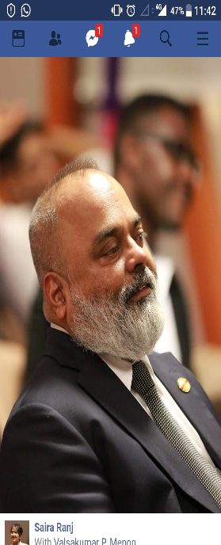

Dear Toastmaster members from Division F,

Happy to connect with you through this newsletter.  Hope you all have been enjoying your Toastmasters journey.  The Toastmasters program is one of the best “learning by doing” self-development program that I have ever come across in my life.  Millions of lives have been transformed because of this program and one among those millions is me.  I was a guy who could not open my mouth in front of an audience around 16 years back, although I was a very senior professional in the corporate world and highly skilled in my job.  But the lack of communication skills, the lack of self-confidence was keeping me down and it was not allowing me to bloom to the extend I could or to the extent that I was capable of blooming or growing.

But then Toastmasters happened and life changed.  The magic of Toastmasters started working on me and slowly and steadily I started enjoying the fruits of being part of this wonderful “learning by doing” program.  Not only did this program help me within the Toastmasters fraternity but more importantly the skills that I developed in the Toastmasters club helped me immensely in my personal and professional life.  Friends, all that achievements and laurels that you earn within Toastmasters is important.  But what is more important is how much of these learnings we are taking and applying in our real life, in our personal life, in our professional life.  How well are we using these learnings to develop and grow in our real life.  How are we using these skills developed over the years in our Toastmasters club to change our life, to make it bigger and better.  This is the question which you need to ask yourself.  Because at the end of the day, this is a program which can create a lot of magic in your real life, but are you putting in the efforts to make that magic happen?

Agreed this is the best “learning by doing” program in this world.  But remember “learning and doing” or in short implementing those learnings, making use of those learnings to add value to your life is what helps bring the best out of you and what helps you to become a bigger and better version of yourself.  So go ahead and allow the Toastmasters magic to work on you.  Wish each one of you the very best in your Toastmasters journey, now and forever.

Warm Regards

**Valsakumar P Menon, DTM**

**Club Growth Director**

Toastmasters International,  
Where Leaders Are Made

